Pricing Optimization Dashboard

Project Overview
The Pricing Optimization Dashboard is an end-to-end Business Intelligence project developed to help an e-commerce business optimize pricing decisions, evaluate profitability, measure discount effectiveness, and monitor overall business performance through data-driven insights.
Built using PostgreSQL, SQL, Excel, and Power BI, the project transforms raw transactional data into an interactive executive reporting solution. It follows the complete Business Intelligence lifecycle—from data preparation and relational database design to data modeling, DAX calculations, visualization, and strategic business reporting.
The solution enables stakeholders to:
- Monitor overall business performance through executive KPIs.
- Analyze pricing strategies across different product categories.
- Evaluate the impact of discounts on revenue, profit, and customer purchasing behavior.
- Identify top-performing and low-performing products using profitability analysis.
- Perform Price Sensitivity (What-If) Scenario Analysis to simulate pricing decisions and estimate their financial impact.
- Analyze revenue, profit, and margin performance across categories and countries.
- Generate strategic business insights based on historical performance.
- Provide data-driven recommendations, action plans, and expected business impact to support executive decision-making.
Rather than serving as a reporting dashboard alone, the project functions as a comprehensive decision-support system, helping management understand current business performance, identify opportunities for improvement, and make informed pricing and profitability decisions.

Business Problem
The e-commerce company generates a significant volume of transactional data every day.
However, despite having access to large amounts of data, management lacks a centralized Business Intelligence solution to transform this information into actionable insights.
As a result, critical business decisions related to pricing, profitability, product performance, and discount strategies are often made without a comprehensive understanding of their financial impact.
The organization required a data-driven solution capable of answering several key business questions, including:
- Is the business operating profitably, and how has overall performance changed over time?
- Which product categories and products generate the highest revenue, profit, and margins?
- Are current pricing strategies effective across different product categories?
- Do discount campaigns drive profitable growth or reduce overall profitability?
- Which products require repricing or optimization?
- How would different pricing scenarios impact future revenue and profit?
- Which markets contribute the most to business growth and profitability?
- What strategic actions can management take to improve overall business performance?
The final dashboard enables management to monitor key business KPIs, evaluate pricing strategies, measure discount effectiveness, analyze product and category performance, perform pricing scenario analysis, and generate strategic recommendations that support informed, data-driven decision-making.

Project Workflow
The project follows a structured Business Intelligence workflow, transforming raw e-commerce data into interactive dashboards and actionable business insights. The process begins with identifying the business problem, followed by data preparation, analysis, dashboard development, and concludes with strategic recommendations to support data-driven decision-making.

The diagram below illustrates the complete end-to-end workflow.

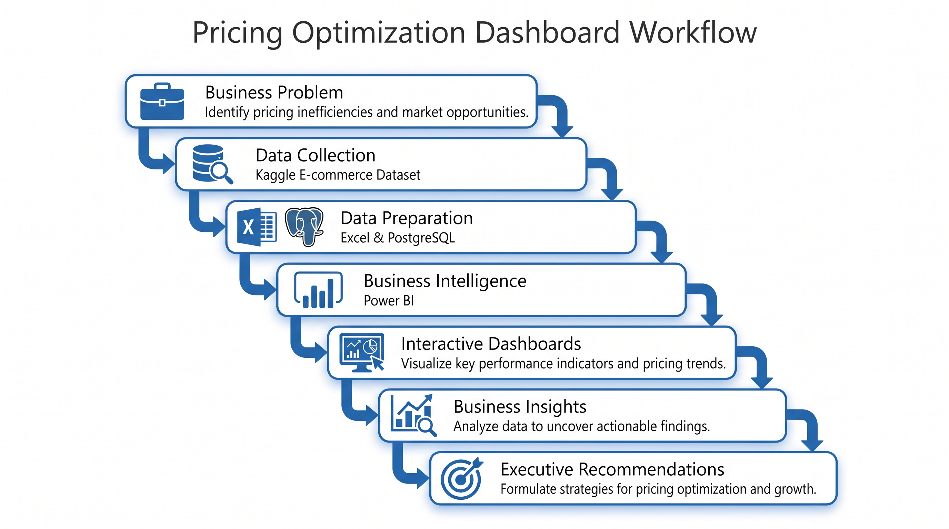

Dataset
This project uses a publicly available synthetic e-commerce dataset from Kaggle. Although the data is not from a real company, it is designed to closely resemble how an actual e-commerce business operates, making it ideal for practicing Business Intelligence and data analysis.
The dataset includes information about customers, products, orders, and order items, allowing realistic analysis of business performance, pricing strategies, profitability, and customer purchasing trends.
Dataset Overview
Dataset Attribute | Details
Source | Kaggle.com
Dataset Type | Synthetic E-commerce Dataset
Time Period | 2020 – 2025
Customers | 20,000
Products | 1,197
Orders | 33,580
Order Items | 59,163

Dataset Files
- customers.csv
- events.csv
- order_items.csv
- orders.csv
- products.csv
- reviews.csv
- sessions.csv

For this project, the analysis focused on the four core transactional datasets:
- customers.csv
- products.csv
- orders.csv
- order_items.csv
The remaining files (sessions.csv, events.csv, and reviews.csv) were not included, as they were outside the scope of the pricing optimization analysis.

Tools & Technologies
The project combines multiple technologies to build a complete Business Intelligence solution, from data preparation to executive reporting.
Tool | Purpose
Microsoft Excel | Initial data review and validation
PostgreSQL | Database creation, data storage, SQL queries, views, and business analysis
pgAdmin 4 | PostgreSQL database management
Power BI Desktop | Dashboard development and visualization
Power Query | Data transformation and cleaning (ETL)
DAX | calculations, measures, and What-If Scenario Analysis
VS Code | SQL script development and project organization
GitHub | Version control and project documentation

Core Skills Demonstrated
- SQL Query Development
- Relational Database Design
- Data Cleaning & Transformation
- Star Schema Data Modeling
- DAX Measure and KPI Development
- Interactive Dashboard Development
- Business Intelligence e & Data Visualization
- Pricing & Profitability Analysis
- Executive Dashboard Design

Database Schema
The project uses a PostgreSQL relational database to organize and analyze the e-commerce data. After importing the raw CSV files, the database was structured using four core transactional tables and several SQL views to support business analysis and dashboard reporting.

Core Tables
- Customers
- Products
- Orders
- Order Items

Analytical SQL Views
- Category Performance
- Pricing Analysis
- Discount Analysis
- Monthly Trends
- Loss-Making Products

PostgreSQL Database Structure
The video below demonstrates the PostgreSQL database structure, including the database schema, tables, analytical SQL views, and sample business queries used to support the Power BI dashboard.
{Pricing-Optimization-Dashboard\Media\02_Postgres_SQL view.mp4}

Dashboard Overview
The dashboard converts raw e-commerce data into interactive reports that help management monitor business performance, evaluate pricing and discount strategies, analyze product profitability, and make data-driven decisions. It consists of seven dedicated pages, each designed to answer a specific business question.

Dashboard Pages
- Business Performance Overview:
Provides an executive summary of overall business performance through KPIs such as revenue, profit, margin, customers, orders, category performance, and country-wise analysis.

- Pricing Analysis:
Analyzes product pricing across different categories to identify pricing patterns, price bands, and pricing opportunities.

- Discount Optimization Analysis:
Evaluates whether discount strategies improve sales performance or reduce profitability through revenue, profit, order volume, and average order value analysis.

- Product Intelligence Dashboard:
Identifies top-performing products, low-performing products, product profitability, and category-level product insights.

- Price Sensitivity & Scenario Analysis:
Uses Power BI What-If Parameters to simulate pricing changes and evaluate their impact on revenue and profitability under different pricing scenarios.

- Strategic Business Insights:
Summarizes the analytical findings into strategic pricing, product, discount, and revenue growth recommendations.

- Executive Recommendations & Business Impact:
Presents the final business recommendations, expected business impact, project limitations, and an executive action plan.

Business Insights
The dashboard uncovered several actionable insights that can support pricing optimization and business growth:
- Home & Kitchen product category generated the highest overall revenue, followed closely by Sports and Fashion, making them the strongest-performing product categories.
- The United States contributed the highest revenue and profit, highlighting it as the company's most valuable market.
- The business maintained a healthy 35.43% profit margin while offering an average discount of 7.16%, indicating strong overall profitability.
- Blanket discount campaigns showed limited business value, as orders without discounts generated the highest revenue and profit.
- Premium-priced products achieved the highest profit margins, suggesting opportunities to maintain premium pricing where customer demand remains stable.
- Price sensitivity analysis showed that moderate price increases significantly improved simulated profitability under constant-demand assumptions.
- Product performance varied considerably within categories, indicating that pricing and inventory decisions should be made at the product level rather than applying a single strategy across entire categories.

Business Recommendations
Based on the analysis, the following strategic recommendations were identified:
- Implement category-specific pricing strategies instead of applying a uniform pricing model across all products.
- Reduce blanket discount campaigns and focus on targeted promotions for selected products or customer segments.
- Continue investing in Home & Kitchen, Sports, and other high-performing categories to maximize revenue growth.
- Expand inventory and marketing efforts for products that consistently generate strong revenue and healthy profit margins.
- Review low-performing and low-margin products to identify opportunities for repricing, cost reduction, or product portfolio optimization.
- Monitor pricing performance regularly using interactive dashboards and key performance indicators (KPIs).
- Use scenario analysis to evaluate potential pricing decisions before implementing business changes.

Author
Bhuvan G Naik
Aspiring Business Analyst | Data Analyst | Business Intelligence Enthusiast

Connect with Me

LinkedIn: https://www.linkedin.com/in/bhuvan-g-naik/
GitHub: https://github.com/bhuvangnaik

If you have any suggestions, feedback, or would like to collaborate on analytics projects, feel free to connect.

